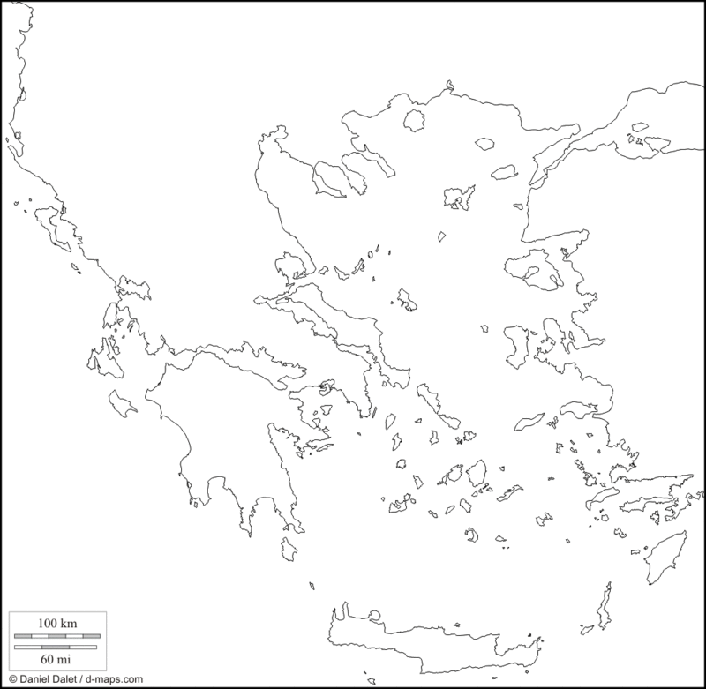

**Your Name _____________________**

**Hour__________**

**Title your map “Ancient Greece” (3pt.)**

**Greece is a peninsula surrounded by water. Color the water blue, and label these three seas (6 pt):**

* Aegean Sea
* Ionian Sea
* Mediterranean Sea

**Color the land masses green. Find and label the following regions in capital letters (10 pt.):**

* MACEDONIA
* ATTICA
* PELOPPONESUS
* IONIA
* ASIA MINOR

**Mark a dot by each of these major cities, and label them in lower case letters (10 pt.):**

* Athens
* Sparta
* Knossos
* Troy
* Mycenae

**Greece has over 3000 islands, but only 227 of them are inhabited. Find and label the following islands (6 pt.):**

* Crete
* Rhodes
* Cyprus

