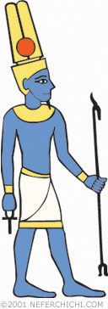 | AMUN  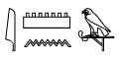  Role: A god of the creation of the earth; the patron god of Thebes; and the king of all the gods of Egypt  Appearance: Form of a man, wearing crown with the sun disc and double feather plumes. Sometimes shown with blue skin.  Sacred animals: ram, goose  Center of worship: Thebes  Relations with other gods: husband of Amaunet in early mythology; part of the Triad of Thebes in later mythology (husband to Mut, father to Khonsu)

Amun's name means "The Hidden One," because he was believed to be the invisible force of the wind. Early Egyptian mythology tells that Amun was a god of creation, forming the earth and the sky with just his thoughts. By the 11th dynasty, Amun was being worshipped as the local patron god of Thebes. As Thebes grew in importance in the New Kingdom, Amun's popularity did too, eventually becoming the official god of all Egypt and the king of all the other gods.
Two huge temples (one at Karnak, the other at Luxor) were dedicated to Amun. The priesthood dedicated to him were very influential, even rivaling the pharaoh's status during the New Kingdom.

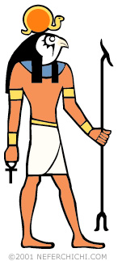 | RE or RA  Role: God of the sun  Appearance: Falcon-headed man with the sun disc on his head  Center of worship: Heliopolis  Relations with other gods: father of Shu and Tefnut, and many other deities including Hathorand Sekhmet

Re had been the main sun god of Egypt since as far back as the Old Kingdom. During the fourth dynasty, pharaohs began to use the title "Son of Re" to remind everyone that they were not mere mortal humans but offspring of the #1 deity! References to Re were even included in the pharaohs' names so they could be associated with him further: Djedefre ("Enduring like Re"), Menkaure("Eternal Like the Souls of Re"), Smenkhkare ("Vigorous is the Soul of Re"), and so on! In later times his role was combined with those of other gods including Amun, Atum, and Harakhte.
As the god of the sun, it was Re's job to make a daily trip across the sky. Starting at the eastern horizon, he sailed a special sun boat across the back of Nut, the goddess of the sky. Twelve hours later, he reached the western horizon, and then travelled another dozen hours through the underworld, where he faced many dangers until he could be reborn at the beginning of the next day.
Because he was such an important god, Re was involved in many Egyptian myths. In one myth, Isis outsmarted him to learn his "secret magic name." In another legend, Re is disgusted by the behavior of humankind so he sends his daughter Sekhmet to punish them, although she gets carried away and nearly wipes out the whole species! Another story that involves other gods and goddesses goes something like this...
Once upon a time, way back when Re was ruling on earth, he had overheard a prophecy that Nut(the goddess of the sky) would one day have a son that would replace him on the throne. Outraged, he cast a spell that forbade Nut to ever give birth to any child on any day of the year. Nut was naturally quite saddened by this so she turned to Thoth, the ibis-head god of wisdom and writing- because if anyone could outsmart the spell, it would be Thoth!

Thoth hatched a plan. He visited Khonsu, the moon god who loved to play the game senet. Thoth challenged Khonsu to a game, and Khonsu couldn't resist- after all, he was confident that he was the best senet player of all, and knew he would enjoy boasting about his victory over the god of wisdom. So when Thoth said that he wanted to play for some of Khonsu's moonlight, Khonsu was not at all worried.
Thoth easily won the first game and got an hour of moonlight as a reward. Anxious to win back his light, Khonsu agreed to another game... and another... and another... but he kept losing! When Thoth finally had won enough hours of light to equal five days, he called it quits. Khonsu was left so exhasted that from that moment on, he could no longer shine a full moon every night. As he got weaker and weaker, the moon got smaller and smaller, until he had to go into hiding to recuperate. As his strength returned, the moon would gradually become larger and larger until it became a full moon- but only for a night; then Khonsu would be sapped of all his strength and the moon would shrink again. So if you haven't figured it out by now, this is how the Egyptians explained how the moon changed phases!
Thoth returned to Nut with five extra days' worth of light. Thoth inserted these five bonus days between the last day of one year and the first day of the next. Since these days were not part of any year, Nut was able to use them to have her children despite Re's curse! Osiris- who would indeed go on to replace Re as the ruler on earth- was born on the first day. On the second day Nut hadSet, followed in order by Isis on the third day, Nephthys on the fourth, and Harmachis on the fifth.
Initially, the ancient Egyptians had thought there were only 360 days in a year, so eventually their calendars got out of synch with their farming seasons. This myth helped account for the need for the five extra days to fix the calendar.

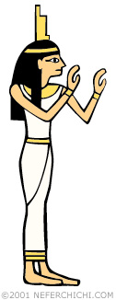 | ISIS  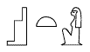  Role: Goddess of motherhood, women, and magic; goddess of the South; protector of Imseti (the son of Horus who watched over the canopic jar containing the liver)  Appearance: Woman wearing the hieroglyph for "throne" on her head  Relations with other gods: part of the Triad of Abydos (wife of Osiris, mother of Horus); Nut(mother); Geb (father); Set and Osiris (brothers),Nephthys (sisters)

When her husband Osiris was killed and dismembered, Isis was seen as a dedicated wife by searching high and low for his remains. It was Isis who supposedly taught the people of Egypt about the institution of marriage. As the mother of Horus, the protector god of kings, Isis represented the ultimate mom.
Isis was the patron goddess of magic and healing and was one of the most powerful deities of ancient Egypt. She was said to know everything on heaven and earth except for one thing: the secret magic name of Re, the god of the sun and king of all the other gods. So Isis hatched a plan to learn it. She made a snake out of dirt and some of Re's spit and laid it down on the ground where he be sure to walk by it. When he stepped on the serpent, it bit him. Isis rushed to Re's side when he called out for help. She told him that she could heal the poisonous bite with a magical spell, but would need to know Re's secret name in order to properly do the incantation. After learning his name, Isis did indeed heal Re, and was all the more powerful in the end!

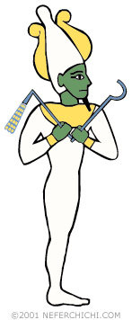 | OSIRIS  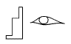  Role: god of the afterlife  Appearance: a green-skinned man wrapped up like a mummy, wearing the Atef crown and holding a crook and flail  Sacred animals: bull  Center of worship: Abydos  Relations with other gods: part of the Triad of Abydos (husband of Isis, father of Horus); Nut(mother); Geb (father); Set (brother), Isis andNephthys (sisters)
Osiris was a very important god throughout Egyptian history. It was believed that while the pharaoh was alive, he was a living version of the god Horus, and when he died he became a version of Osiris in the afterlife.
THE MYTH
According to Egyptian mythology, Nut (the goddess of the sky) and Geb (the god of the earth) had five children: Osiris, Set, Isis, Nephthys, and Harmachis. Osiris and his sister Isis were paired together, as were Set and Nephthys. Osiris had green skin because he was a god of agriculture, vegetation, and fertility. As a god on earth, he was the first pharaoh and taught his people how to grow corn and make wine from grapes and bread and beer from wheat. He taught the people about the gods and built the first temples where they could worship them.
Everyone loved Osiris, except for his jealous brother Set, the donkey-headed god of the desert. Set came up with a plan to get rid of Osiris and to become the new king. He threw a huge banquet and invited Osiris. During the meal, Set brought out a beautifully decorated human-shaped box and announced that he would give it to whichever party guest fit in it perfectly. So one at a time the guests laid down in the box, but they were either too tall or too short, or too thin or too fat for it to be a perfect fit. But when Osiris took his turn, his body fit the box perfectly. At that exact moment, Set and his 72 accomplices rushed forward, slammed down the lid, and sealed it shut with molten lead. Then they threw it out into the Nile where it sailed out into the Mediterranean Sea. Osiris suffocated inside the box and Set became the new king. Isis was devastated, but as a dedicated wife she went out looking for her husband.
The chest floated all the way to the shore of Byblos, where it washed up against a young tamarisk tree. Even though he was dead, Osiris's body still had magical powers of vegetation, which caused the tamarisk tree to suddenly shoot up to full size, wrapping around the chest, enclosing it within the tree completely.
The king of Byblos noticed a giant tree where there hadn't been one the day before, so he knew it had to be special. He ordered it cut down and made into a column for his palace. When the tree was cut, it released a powerful and beautiful scent that was so powerful that even Isis could smell it. The fragrant smell drew her all the way to Byblos. The king was sympathetic to Isis so he let her cut Osiris out of the wood and bring him back to Egypt.
Isis hid the body of Osiris in the swamps of Lower Egypt, but Set found out and was furious. To eliminate Osiris once and for all, he cut the body into 14 pieces and scattered them all over Egypt. Isis again set off looking for her husband. She bundled up all the parts of his body in a large linen sheet as she found them. After she recovered all 14 pieces, she sought the help of Anubis to reassemble the body and bring him back to life. But the rules of the universe applied to the gods as well as people, so he was not allowed to return to the world of the living. Instead, he went on to the afterlife, where he again ruled as king.
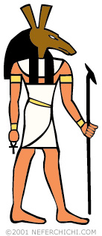 | SET  Role: God of chaos, evil, the desert, war, violence, conflict, and sandstorms (all bad things!)  Appearance: Form of a man, with the head of an unidentified donkey-like animal. He was sometimes seen as a pig or a hippo.  Sacred animal: the mythical "Set animal" (see below)  Relations with other gods: Nut (mother); Geb(father); Osiris (brother), Isis and Nephthys(sisters)

One of the recurring themes in ancient Egyptian culture is duality-- everything appearing in opposite pairs. Upper Egypt and Lower Egypt, papyrus and lotus, cobra and vulture, Isis and Nephthys. Look at a typical mummy and you'll notice how the images are symmetrically paired on the left and right. And it wasn't just on mummies, either. Spend some time looking at Egyptian art and architechture and you'll see how this "two-ness" was everywhere!
Such was the case with the constant battle of good vs. evil, as represented byHorus and Set. According to Egyptian mythology, jealous Set murdered his brother Osiris in order to seize the throne. Osiris's son Horus avenged his father's death by battling Set in a bloody war that lasted for a very long time. The fight was only finally settled by a panel of gods: They ruled that Set must be punished so it became his job to travel with Re in his sun boat as it sailed across the sky, standing ready to protect the sun from the Apophis serpent (a giant evil snake that threatened to disrupt the daily journey of the sun).

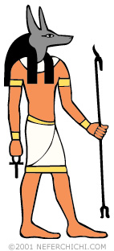 | ANUBIS  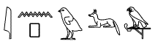  Role: God of mummification  Appearance: Jackal or a jackal-headed man  Sacred animals: jackal  Relations with other gods: Nephthys (mother),Set (father)

Anubis was worshipped widely throughout Egypt. In one myth, Anubis restored eternal life to Osirisso he could go on to rule the world of the dead.
As the god of mummification, Anubis was believed to watch over the process to make sure it was done correctly. The chief embalmer would wear a mask of Anubis to represent his presence during the mummification process.
Anubis also escorted the souls of the dead to the afterlife, and participated in a special judgement ceremony called "The Weighing of the Heart" which determined whether or not the person could go on to Osiris.
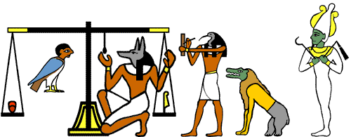

MA'AT
Role: Goddess of law, truth, and order
Appearance: Woman with an ostrich feather on her head
Relations with other gods: wife of Thoth

The goddess Ma'at is a personification of the ideas of law, truth, and order. In fact, the word "ma'at" described the state of worldwide balance and order.
Ma'at had a role in the judgement of the dead. In "The Hall of Ma'at" the heart of the deceased was weighed against Ma'at's "feather of truth." If the heart was free of guilt and sin, it would be lighter and the sould would get to pass on to Osiris. But if the heart was heavy with sin, it is thrown toAmmut, who gobbles it up, denying the spirit an afterlife and causing it to cease to exist.

