Sewer System

In larger Roman towns, people often got sick or died from drinking water that had been contaminated with sewage. Sewage is human waste . When people drink water with waste in it, they can get other people's germs and get sick with dysentery or die. To fix this problem, many Roman towns built aqueducts to bring in fresh water from the hills outside of the towns. They also built public latrines and systems of sewage pipes to carry sewage out of the streets and dump it into the river. This was a big improvement on Greek sewage arrangements, where people just poured their waste into the street however they wanted.
There were also big public toilets that had room for lots of people at the same time. These sewers just dumped raw sewage into the river, which was better than leaving it lying around in the streets, but still did spread germs sometimes. The Romans didn't have any way of treating sewage to kill the germs, as we do today, and they didn't understand the need to do that. Some of these sewers are still being used today.

Aqueduct

As Roman towns got bigger, in the course of the Roman Republic, it got too hard for the people who lived in the towns to get drinking and washing water. Because raw sewage was draining into the rivers, people who drank river water often got very sick or died. Local governments, first in the city of Rome and then elsewhere in the growing Empire, decided to build long stone channels to carry clean water from nearby hills to the towns. This is an aqueduct of the city of Rome. These were called aqueducts (ACK-wa-ducts), from the Latin word for water (aqua) and the Latin word for channel (ductus). By the time of the Empire, most Roman towns had at least one aqueduct to bring in fresh water, and big cities like Rome had ten or more. These aqueducts were quite a challenge to build. The engineering had to be just right in order to get the water to run through the channels and get to the city without stagnating in the channel or coming too fast into the city. They had to keep the slope the same all the time, so sometimes the aqueducts had to run on high arches, and other times along the ground in stone channels, or even under the ground in tunnels. Roman engineers built aqueducts all over the Roman Empire, from Syria to England. All Roman towns pretty much got clean drinking water from these aqueducts.

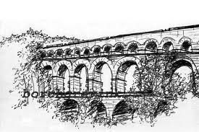

Paved Roads

The Roman roads were a vital part of the development of the Roman state, from about 500 BC through the expansion during the Roman Republic and the Roman Empire. Roman roads enabled the Romans to move armies and trade goods and to communicate. The Roman road system spanned more than 400,000 km of roads, including over 80,500 km of paved roads. When Rome reached the height of its power, no fewer than 29 great military highways radiated from the city. Hills were cut through and deep ravines filled in. At one point, the Roman Empire was divided into 113 provinces traversed by 372 great road links. In Gaul alone, no less than 21,000 km of road are said to have been improved, and in Britain at least 4,000 km. There were footpaths on each side of the road.
The Romans became adept at constructing roads, which they called viae. They were intended for carrying material from one location to another. It was permitted to walk or pass and drive cattle, vehicles, or traffic of any description along the path. The viae differed from the many other smaller or rougher roads, bridle-paths, drifts, and tracks. To make the roads the Romans used stones, broken stones mixed with cement and sand, cement mixed with broken tiles, curving stones - so the water could drain, and on the top they used tightly packed paving stones.
The Roman road networks were important both in maintaining the stability of the empire and for its expansion. The legions made good time on them, and some are still used millennia later. In later antiquity, these roads played an important part in Roman military reverses by offering avenues of invasion to the barbarians.

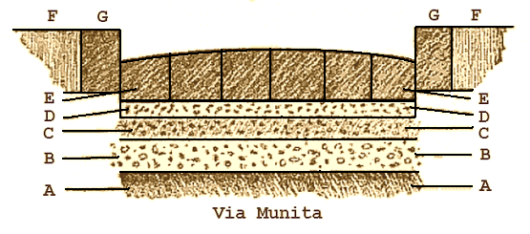
The general appearance of such a metalled road and footway is shown in an existing street of Pompeii.
(A). Native earth, levelled and, if necessary, rammed tight.
(B). Statumen: stones of a size to fill the hand.
(C). Audits: rubble or concrete of broken stones and lime.
(D). Nucleus : kernel or bedding of fine cement made of pounded potshards and lime.
(E). Dorsum or agger viae : the elliptical surface or crown of the road (media stratae eminentia) made of polygonal blocks of silex (basaltic lava) or rectangular blocks of saxum qitadratum (travertine, peperino, or other stone of the country). The upper surface was designed to cast off rain or water like the shell of a tortoise. The lower surfaces of the separate stones, here shown as flat, were sometimes cut to a point or edge in order to grasp the nucleus, or next layer, more firmly.
(F). Crepido, margo or semita : raised footway, or sidewalk, on each side of the via.
(G). Umbones or edge-stones.

Dome

Now suppose you want to make a dome. How would you do that using the idea of the arch? This is harder, but basically a dome is an arch turned around and around. People did not get this idea until the time of the Roman Empire, around 100 AD. A famous early example of a dome is Hadrian's Pantheon in Rome. Another great dome from the ancient world is the one in Hagia Sophia, in Constantinople, which was built under the Emperor Justinian in the 500s AD. During the Islamic Empire, in West Asia, architects there built the Dome of the Rock mosque in Jerusalem in the 600s AD, and, in the 700s, the Great Mosque of Damascus, which also has a dome. In the 800s, the Abbasids built the Great Mosque at Kairouan in North Africa, also with a small dome. Why would being able to build a dome help the Romans?

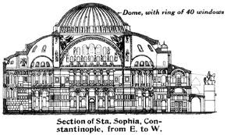

Arch

The ancient Romans learned the arch from the Etruscans, refined it and were the first builders to tap its full potential for above ground buildings:
The Romans were the first builders in Europe, perhaps the first in the world, fully to appreciate the advantages of the arch, the vault and the dome.
Throughout the Roman empire, their engineers erected arch structures such as bridges, aqueducts, and gates. They also introduced the triumphal arch as a military monument. Vaults began to be used for roofing large interior spaces such as halls and temples, a function which was also assumed by domed structures from the 1st century BC onwards.
The segmental arch was first built by the Romans who realized that an arch in a bridge did not have to be a semicircle, such as in Alconétar Bridge or Ponte San Lorenzo. They were also routinely used in house construction as in Ostia Antica. The semicircular arch was followed in Europe by the pointed Gothic arch or ogive whose centreline more closely followed the forces of compression and which was therefore stronger. The semicircular arch can be flattened to make an elliptical arch as in the Ponte Santa Trinita. Both the parabolic and the catenary arches are now known to be the theoretically strongest forms. Parabolic arches were introduced in construction by the Spanish architect Antoni Gaudí, who admired the structural system of Gothic style, but for the buttresses, which he termed “architectural crutches”. The catenary and parabolic arches carry all horizontal thrust to the foundation and so do not need additional elements.

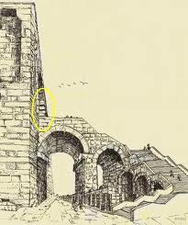
Bath House
Roman people usually didn't have hot baths in their houses, because it was too hard to heat up the water. And people who lived in cities had to live in small apartments, often a whole family in one room, and so they didn't have room for baths or any yard to exercise in. So instead they used to go to public baths.
Public baths were something like our community centers today, or like a health club. They had swimming pools fed byaqueducts, and hot tubs, and exercise equipment, and often gardens and libraries and theaters as well. Some of them had temples, like the Mithraeum in the Baths of Caracalla. Like community centers, you had to pay a small fee to get in, but they sometimes also had free days.
But unlike most community centers today, Roman baths were made to be really impressive, beautiful buildings. They had high, vaulted ceilings, and the walls were decorated with marble and frescoes. The floors had complicated mosaics.
Pretty much any town in the Roman Empire had at least one bath building, and many had more than one. Army camps had them, too. But of course the biggest, fanciest ones were in the city of Rome.
Roman engineers devised an ingenious system of heating the baths. The floor was raised off the ground by pillars. Spaces were left in the walls so hot air from the furnace could pass through the open areas. Rooms requiring the most heat were placed closest to the furnace. Not only was the water heated, the floor was heated as well.

