Week 2- Ancient Rome
Self-Assessment

 | I’ve got it | I’m Working on it | I Don’t understand
I can name the two classes of citizens in Rome.
I can describe the general structure of the Roman republic. I know the terms consul, senate, and plebian assembly.
I can explain how individual actors influenced the Punic Wars.
I can explain the major effects of the Punic Wars. I can describe Hannibal.
I can explain how Rome’s republic fell and became an empire. I can describe Julius Caesar.

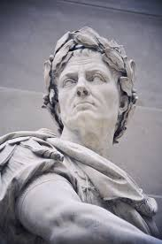
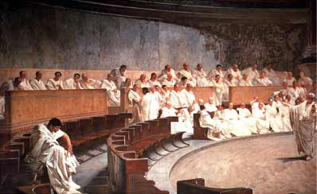
Republic to Empire

