Week 3- Ancient Rome
Self-Assessment

 | I’ve got it | I’m Working on it | I Don’t understand
I can define triumvirate.
I can describe Octavian Augustus and know why he is important.
I can list areas conquered by Rome.
I can explain at least three reasons that the Roman republic was successful.
I can describe engineering feats of the Romans, including roads, aqueducts, concrete, and use of the arch. I can identify the colosseum, the circus maximus, roman baths, the pantheon, and the catacombs.

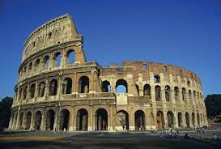
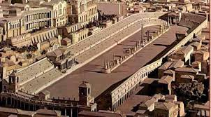
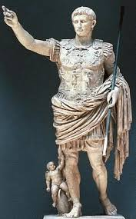
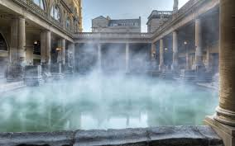
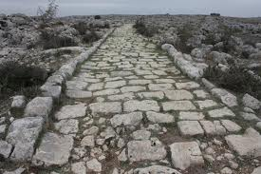
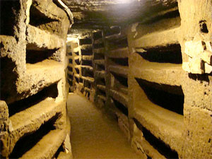
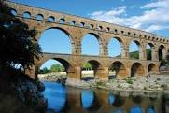
Pax Romana

