|  |  |  |  |
| --- | --- | --- | --- |
|  | I’ve got it | I’m working on it | I need more help |
| I can read a map of Egypt. I understand how the Nile River and the desert surrounding Egypt influenced its civilization. I know the terms *delta* and *inundation.* |  |  |  |
| I can describe the central importance of the Nile to Egypt’s economy and describe Egypt’s sources of wealth. |  |  |  |
| I can describe the government of Egypt. I know the terms *pharaoh* and *theocracy*. I can describe how King Menes united Egypt and can identify the Upper and Lower Kingdoms of Egypt. I can describe the knowledge gained from King Tutankhamen’s tomb, and the unusual reign of the pharaoh Hatshepsut. |  |  |  |
| I can describe Egypt’s social structure. I can describe daily life in Egypt. I know the terms *pectoral* and *linen*. |  |  |  |
| I can describe Egypt’s religion. I can explain Egypt’s mummification process and the building of pyramids. I know the terms *mummy, sarcophagus,* and  *canopic jars.* I can describe the impact of Ahknaten’s reign and know the terms *monotheism* and *polytheism.* I know the major Egyptian gods *Osiris, Isis, Amun, Ra, Set, Anubis, Ma’at..* |  |  |  |
| I can describe Egyptian architecture. I know the terms *obelisk, pyramid, sphinx, quarry.* I can describe art using the terms *fresco* and *faience.* |  |  |  |
| I can describe the writing systems of ancient Egypt. I know what the Rosetta stone was, and its importance. I know the terms *hieroglyphs, demotic script, scribe,* and *papyrus.* |  |  |  |

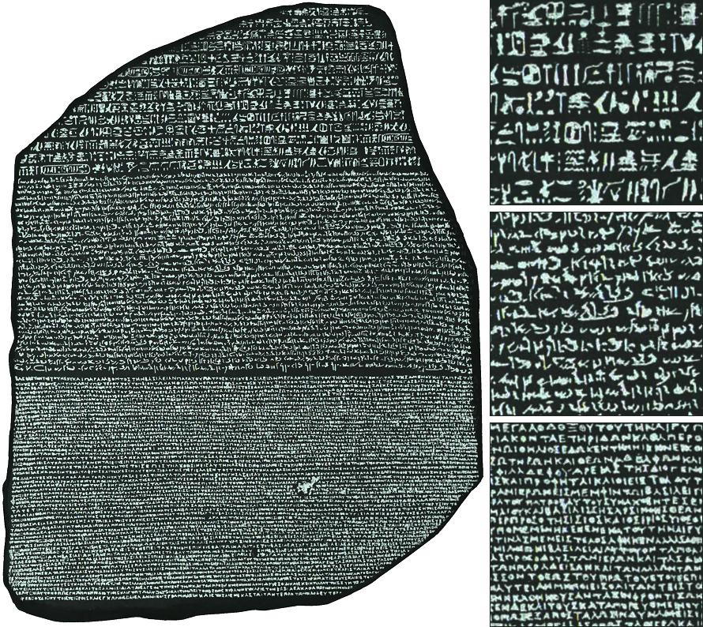 Social Studies Self-Assessment 5- Egypt

