Social Studies Week 1 Objectives- Map Skills Unit
 | I’ve got it | I’m working on it | I need more help
I can name the 4 cardinal directions and use them to navigate.
I can name the 7 world continents and 4 oceans.
I can identify the equator, prime meridian, Tropic of Cancer Tropic of Capricorn, and the hemispheres.
I can explain the difference between a primary and secondary source.
I know how to track my learning progress in class.

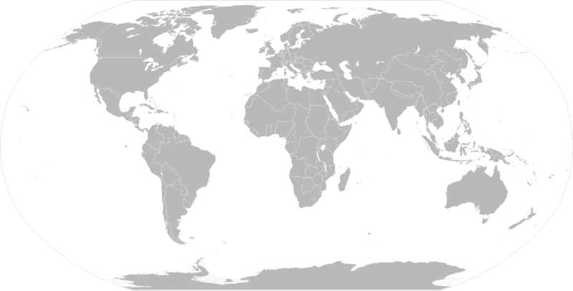

Social Studies Week 2 Objectives- Map Skills Unit
 | I’ve got it | I’m working on it | I need more help
I can describe the 7 continents.
I can describe the features of civilizations.
I can work productively with a partner by staying focused on the assigned task.
I can use poise when speaking in a group.

