 | I’ve got it | I’m working on it | I need more help
I can describe life during the Paleolithic Era.
I can describe life during the Neolithic Era.
I can explain how hunter-gatherers transitioned to agricultural civilizations and the effects of this change.
I can explain how geography affected early civilizations.
I can answer a question using RARE format.
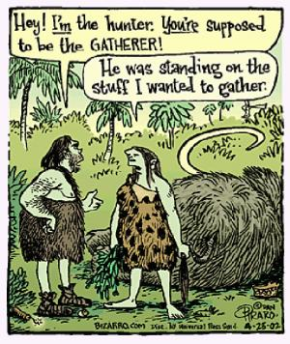
Social Studies Self-Assessment 3

