Read pages 30-35 in your Social Studies Textbook. Take Cornell notes on these 5
pages by wrting down the key terms or topics on the left, notes of the main ideas
for each topic on the right, and a summary of the reading at the bottom of the page.
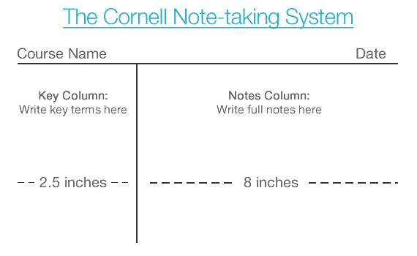

Summary:
Create a brief restatement of the main points here
xdsfs