Types of Maps
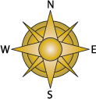
Maps are pictures or representations of the Earth's surface. They show how places are related to each other by distance, direction, and size. Maps are a way of showing a part of the Earth's surface on a flat piece of paper.
Maps are flat but they are made to represent an area that is on a sphere, Earth. This can cause what is called distortion (changes in the shape of an object). The areas of a map closest to the equator have little distortion. The closer a map moves towards the poles the more distorted the map becomes. For example, Greenland appears to be much larger on a map than it really is.
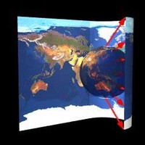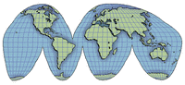
A person who makes maps is called a cartographer.
A map includes a compass rose that shows direction. Cardinal Directions are the four base parts on a compass. The top point is called north and the point at the bottom is south. The side points are called east and west. The points in between the cardinal directions are called intermediate directions. These include northwest, northeast, southwest, and southeast.
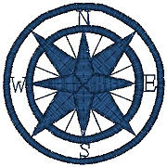
Maps have keys. The objects on a map are represented using symbols. A symbol is a picture on the map that represents something in the real world. To understand the symbols on a map you need a key. Maps use a key, or legend to explain the meaning of each of the symbols used in the map. The key usually shows a small picture of each of the symbols used on the map, along with a written description of the meaning of each symbol.
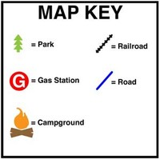
Maps have scales. Maps are scaled down so that they fit on paper. When scaling down a map, every part of the map is scaled by the same amount. This is done to make sure that every object on the map is the same proportion as everything else on the map. Because the Earth is round, and maps are flat, it is impossible to create a map with a perfect scale. Some parts of the map will be too large, while others will be too small.
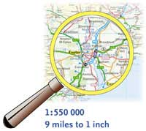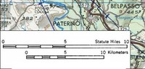

You can read a map or globe. We can identify locations on the Earth's surface by using a grid system of latitude and longitude. Latitude gives a north and south direction and longitude gives an east and west direction. This system helps us in measuring distances and finding directions between places on the Earth's surface. The starting point is the prime meridian, with represents 0º longitude. The exact opposite position at 180º is called the International Date Line, which is where the date actually changes.
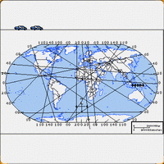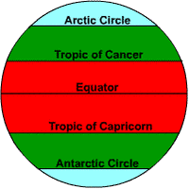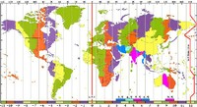
Climate Maps - give general information about the climate and precipitation (rain and snow) of a region. Cartographers, or mapmakers, use colors to show different climate or precipitation zones.
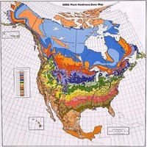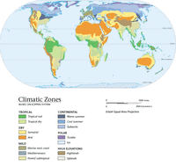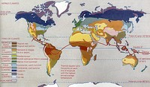
Economic or Resource Maps - feature the major types of natural resources or economic activity in an area. Cartographers use symbols to show the locations of natural resources or economic activities. For example, wheat on a map of Maryland tells you that wheat is grown there.
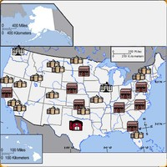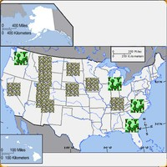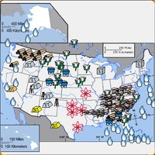
Physical Maps - illustrate the physical features of an area, such as the mountains, rivers and lakes. The water is usually shown in blue. Colors are used to show relief—differences in land elevations. Green is usually used at lower elevations, and orange or brown show higher elevations.
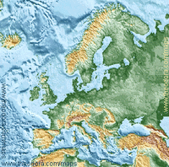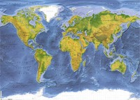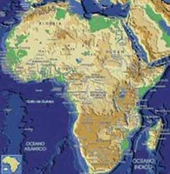
Political Maps - do not show physical features. Instead, they show state and national boundaries and capital and major cities. A capital city is usually marked with a star within a circle.
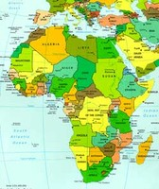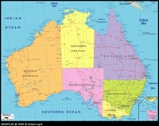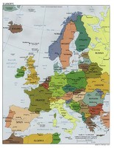
Street Maps/Road Maps - street maps illustrate smaller areas such as towns and cities. People use street maps to find directions to a place they want to go. A road map shows the highways or interstates. These maps are also used to find directions.
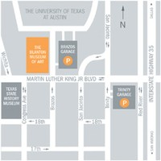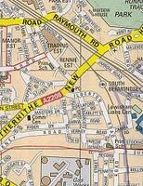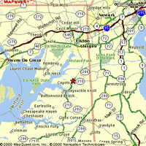

Topographic Maps - include contour lines to show the shape and elevation of an area. Lines that are close together show steep terrain, and lines that are far apart show flat terrain. Many hikers use topographic maps, especially in areas where there are no roads with signs. Geologists depend on topographic maps to record the types of rocks. Engineers use topographic maps when they are planning roads, buildings, or other human–made structures.
